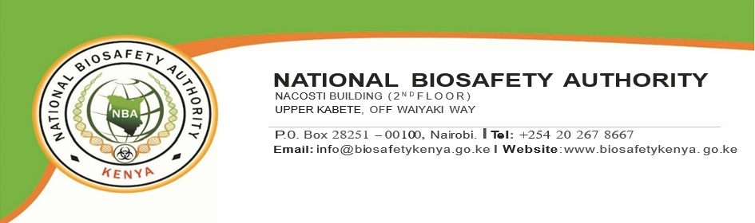

RELOCATION TO NEW HEADQUARTERS

Dear Esteemed Customers:

We are pleased to inform you that with effect from 1st February 2021, The National Biosafety Authority (NBA) relocated to NACOSTI Building (2nd Floor) located in the Upper Kabete off Waiyaki Way, Nairobi.

Our Postal Address, Telephone, and Social media contacts remain unchanged. We look forward to seeing and serving you better.

Physical address: NACOSTI Building, Loresho, Off Waiyaki Way.
Postal address: P.O. Box 28251 / 00100, Nairobi, Kenya
Tel: 0202678667
Cell: 0713854132

