DATE: 23rd MARCH 2020

TO ALL STAKEHOLDERS
In response to the Kenyan Government’s directive in regard to the Covid -19 (novel Coronavirus) pandemic, the Authority has implemented ‘work from home” strategy with only very few staff working from the offices. Consequently, the Authority encourages you to minimize physical visits to NBA offices and utilize our online platforms instead.

For any services the Authority may be reached through info@biosafetykenya.go.ke/ceo@biosafetykenya.go.ke and Telephone number 0713854132/020 2678667. We will be working remotely and our emails are going to remain open from 8:00 am – 5:00 pm as stipulated in our working hours. This will remain in force until advised otherwise.

Thank you for your understanding.
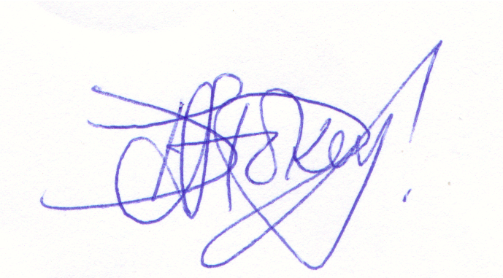
PROF. DORINGTON OGOYI
CHIEF EXECUTIVE OFFICER

